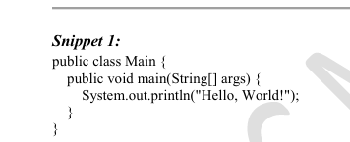

ERROR:



CORRECTION:

public class Main {

public **static** void main(String[] args) {

System.out.println("Hello, World!");

}

}

RESULT:

Hello, World!

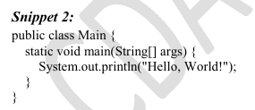

ERROR:

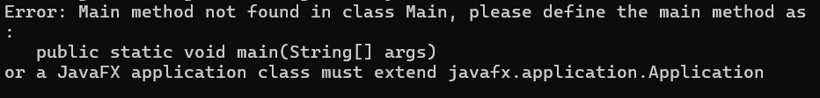

CORRECTION:

public class Main {

**public** static void main(String[] args) {

System.out.println("Hello, World!");

}

}

RESULT:

Hello, World!

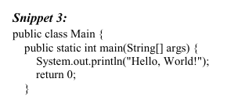

ERROR:



CORRECTION:

public class Main {

public static void main(String[] args) {

System.out.println("Hello, World!");

}

}

RESULT:

Hello, World!

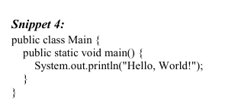

ERROR:

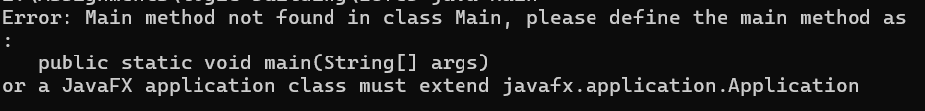

CORRECTION:

public class Main {

public static void main(String[] args) {

System.out.println("Hello, World!");

}

}

RESULT:

Hello, World!

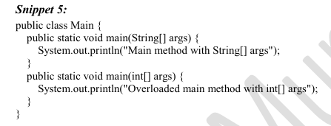

OUTCOME:



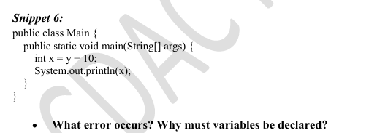

ERROR:

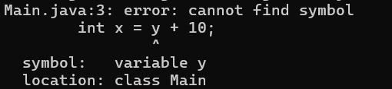

CORRECTION:

public class Main {

public static void main(String[] args) {

**int y = 5;**

int x = y + 10;

System.out.println(x);

}

}

RESULT:

15

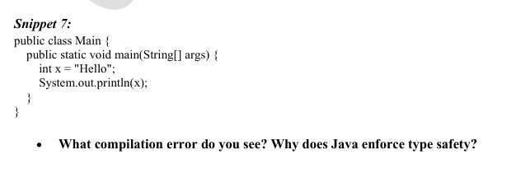

ERROR:



CORRECTION:

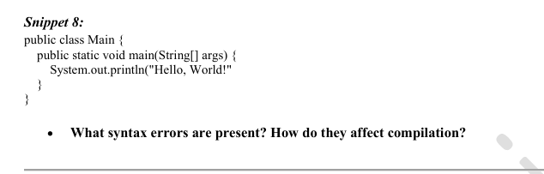

ERROR:

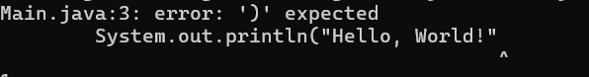



CORRECTION:

public class Main {

public static void main(String[] args) {

System.out.println("Hello, World!");

}

}

RESULT:

Hello, World!

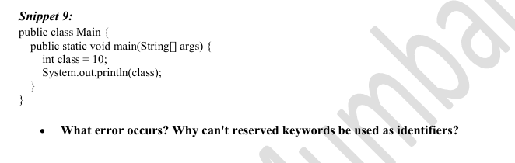

ERROR:

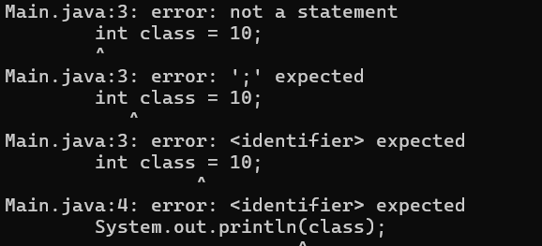

CORRECTION:

public class Main {

public static void main(String[] args) {

int **a** = 10;

System.out.println(**a**);

}

}

RESULT:

10

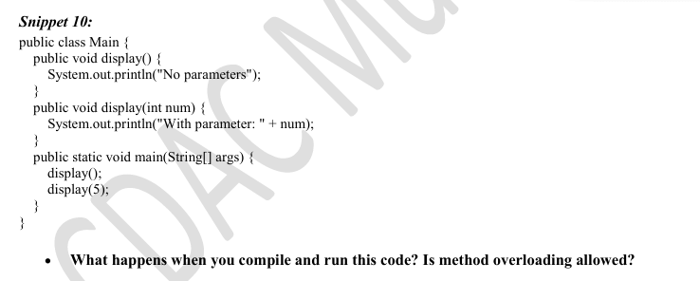

ERROR:

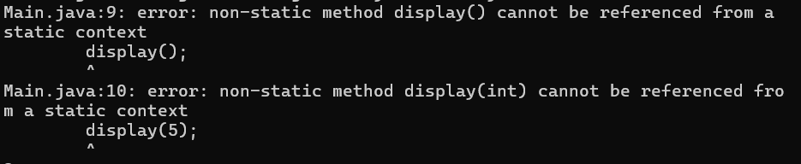

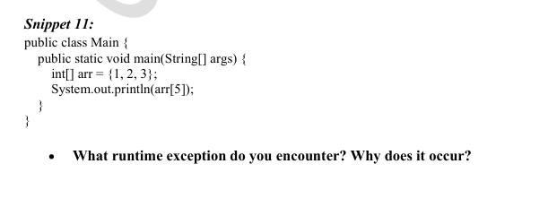

ERROR:



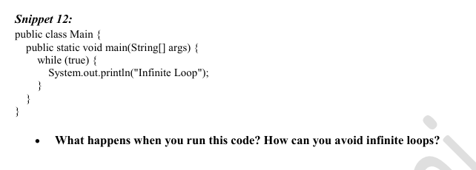

When the condition is true,Infinite loop occurs.

When the condition is false, ERROR: unreachable statement occurs

We can manually stop it by

